Result presented above is to check that simulation works as expected by showing that resulted expectation value of escape rate becomes more stable (variance decrease to zero) as sample size increases. Left is partition function; right is zeta function. 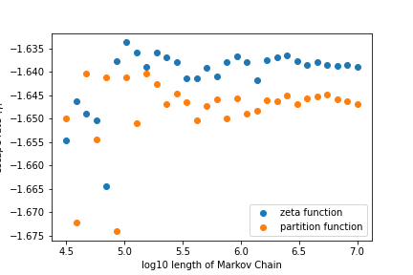t is zeta function.

Result discussion

* Sanity check shows that both simulations converge, as variance decreases to zero.
* Correspondence between zeta function and partition function shows a possible relative difference of 0.3%, which might be due to the numerical effect of truncation in zeta function or the mere randomness of simulation.

Simulation setup

* Use classical $ϕ^{4}$ theory as an example in this project.
* The program that finds all the periodic states and prime orbits of $ϕ^{4}$ theory is preliminary.
* The transition probability is given by stability exponent, which can be easily calculated based on periodic solutions given.

This figure above shows expectation value of escape rate evaluated from partition sum and zeta function for various sample sizes for MCMC simulation. Both sum rums up to periodic solutions with period 10 in one temporal dimension.

Background

* Partition function in lattice field theory is based on periodic states and can be truncated as finite sum, thus rarely computed by MCMC.
* Zeta function is based on prime orbits, related to generating function of partition function, and cannot be truncated.
* However, zeta function is more robust because of its convergence rate and analyticity, but it comes with the problem of formal infinite sum.
* In this project, we take advantage of MCMC simulation to check the correspondence of zeta function and partition function in terms of evaluation.

Future work

* Optimize algorithm for identifying prime orbit to evaluate with longer period.
* Write both zeta function and generating partition function as cumulant sums and develop a method to the coefficients, then compare the analytical result from zeta function to simulation.
* Based on this result, develop a probability measure, and apply time evolution operator to check invariance condition.
* Apply this model to lattice field theories with higher spatiotemporal dimension.

